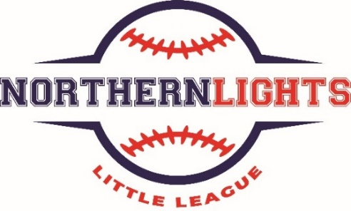

2026 All Star Team Paperwork Requirements

PLEASE READ CAREFULLY (I will need Three Hardcopies of Everything Below. PLEASE DO NOT EMAIL ME THE DOCUMENTS)

Please gather all the below together (three copies of each), put in an envelope with my name on it, and bring this with you to the tryouts on May 15th - May 17th.

Little League requires a lot of paperwork for tournament teams.

Residency Eligibility Documents (Read this Carefully) -- Need Three Hard Copies

This will be the most complex of the required forms because Little League has specific paperwork requirements that must be followed exactly or they will reject the forms. You have two options to satisfy this requirement.

Option #1 (Use School Address) -- Little League's provided school enrollment form located HERE or https://www.littleleague.org/downloads/school-enrollment-form/.

If you use this, the field that says "This student has been enrolled as of" must be prior to October 1, 2025. If they enrolled in that school after September 30, 2025, the Form will not count. You need someone from the school to sign the form.

Option #2 (Use Home Address) -- If you need to use your home address to confirm residency eligible, please carefully review THIS DOCUMENT https://www.littleleague.org/downloads/residency-checklist/ that outlines the specific requirements. We need three separate forms, one from each group, and any documents that is like a monthly bill must be dated between February 1, 2025 and February 1, 2026 and must have the entire address on them. A copy of the envelope of a bill with the address will NOT suffice. Additionally, a utility bill from April or May 2026 won't work. Please make sure you grab one from each of the three groups. The City of Thornton Water bill is great because that is one that fulfills either Group 2 or 3 (not both though). My recommendation would be (1) Driver's license (not expired), (2) City of Thornton, (3) Xcel Energy or Xfinity. That combination works well assuming the last two are dated between February 1, 2025 and February 1, 2026 and the driver’s license is not expired.

Copy of Birth Certificate -- Need Three Hard copies

Need a COPY of your son's birth certificate. Please do not provide the original. Provide three hard copies.

Medical Release Forms -- Need Three Hard copies

I know you completed these already for the regular season but those need to stay with the Team Manager for the regular season. We need a new one and we need three copies of it.

https://www.littleleague.org/downloads/medical-release-form/

$75 Cash/Check

We will be purchasing uniforms and awesome hats so we ask for $75 to pay for this and other costs. If you need help, we can potentially offer a scholarship. This is NOT required at tryouts. This will only be required if selected to be on an All Star team.

